**1)UNION Operator:**

The UNION operator combines the result sets of two or more SELECT statements into a single result set.

It removes duplicate rows from the combined result set by default.

The columns in the SELECT statements must have compatible data types, and the number of columns in each SELECT statement must be the same.

The order of rows in the final result set may not be the same as in the individual SELECT statements unless you use the ORDER BY clause.

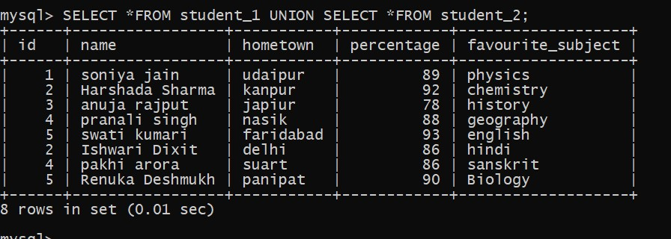

**2)UNION ALL Operator:**

The UNION ALL operator returns all the rows from both queries, including the duplicates.

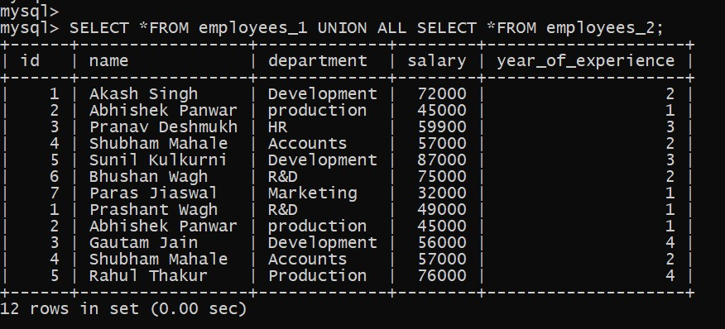

**3)EXCEPT Operator:**

The EXCEPT operator retrieves the rows present in the first result set but not in the second result set.

It returns distinct rows from the first result set that do not have corresponding rows in the second result set.

The columns in both SELECT statements must have compatible data types, and the number of columns in both statements must be the same.

**4)INTERSECT Operator:**

The INTERSECT operator is used to retrieve the rows that are common to both result sets.

It returns distinct rows appearing in the first and second result sets.

The columns in both SELECT statements must have compatible data types, and the number of columns in both statements must be the same.

